How to apply for a commercial construction permit:
Go to www.west-chester.com
Go to Permitting & Licensing Portal:
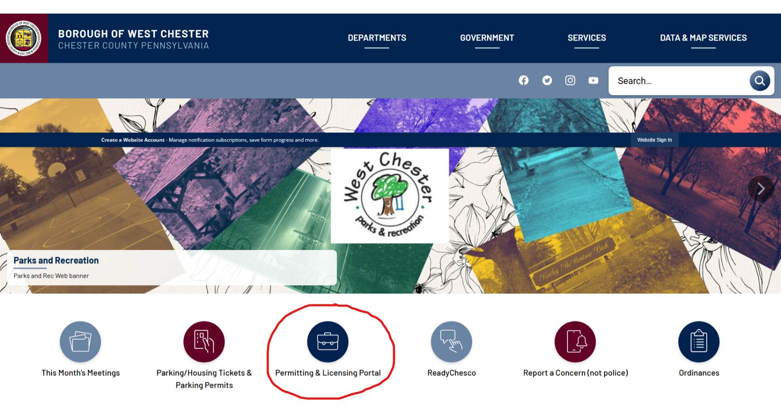
Sign up or Log in:
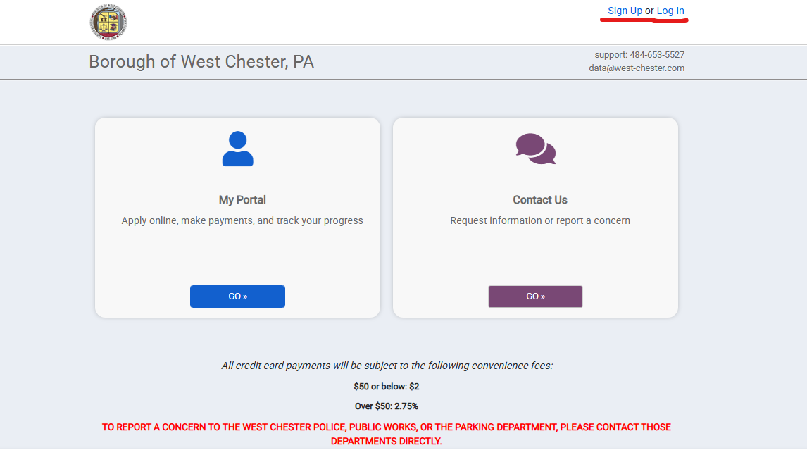
To create an account, provide the following information: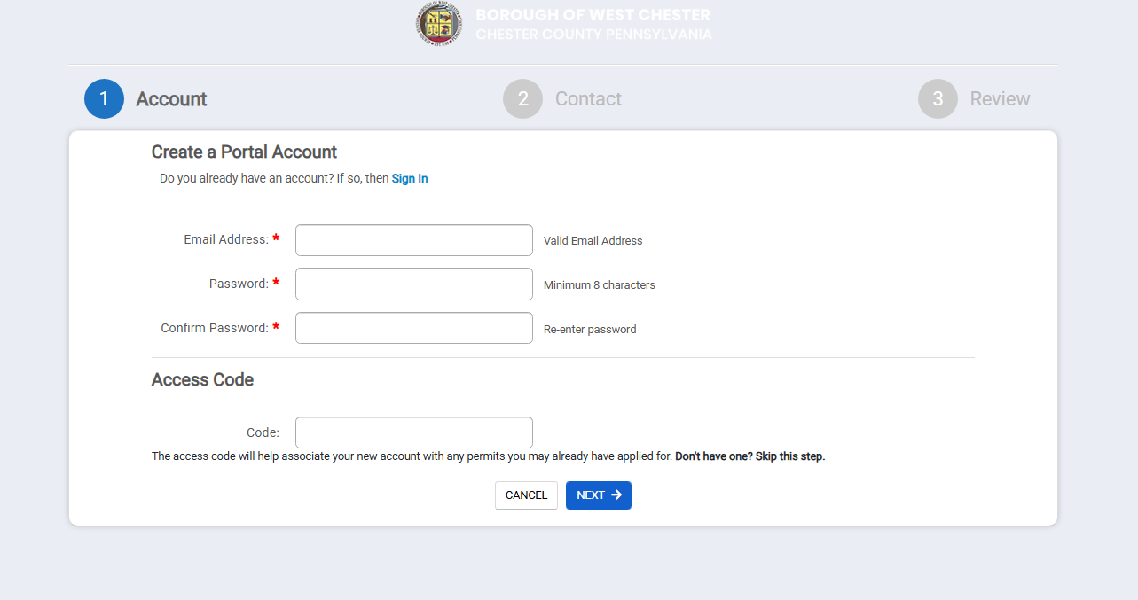
To log in:
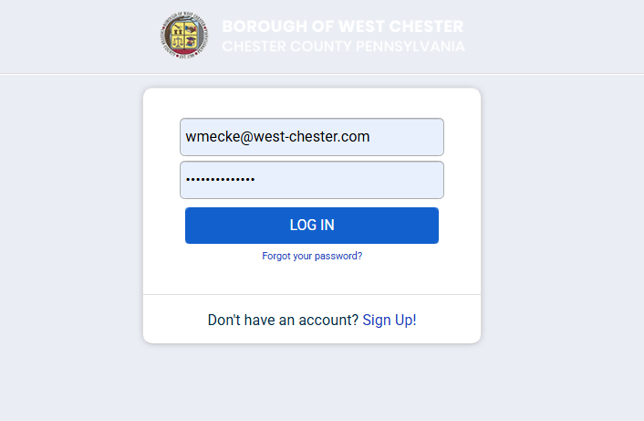

Apply for Commericial-Addition, Alteration, Repair application:
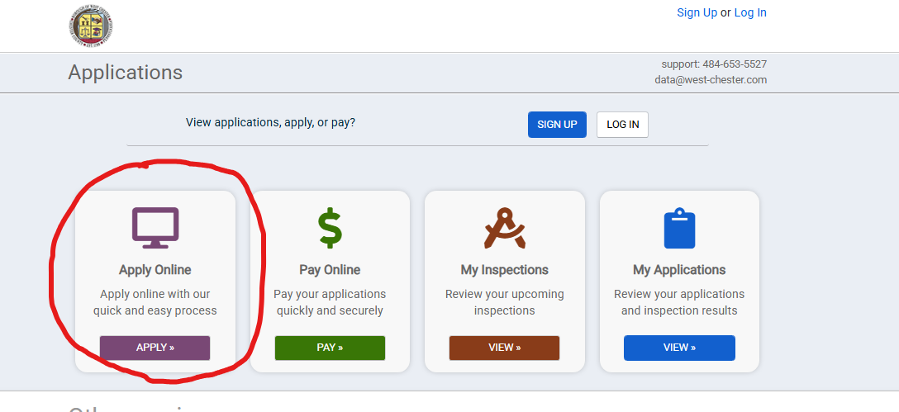
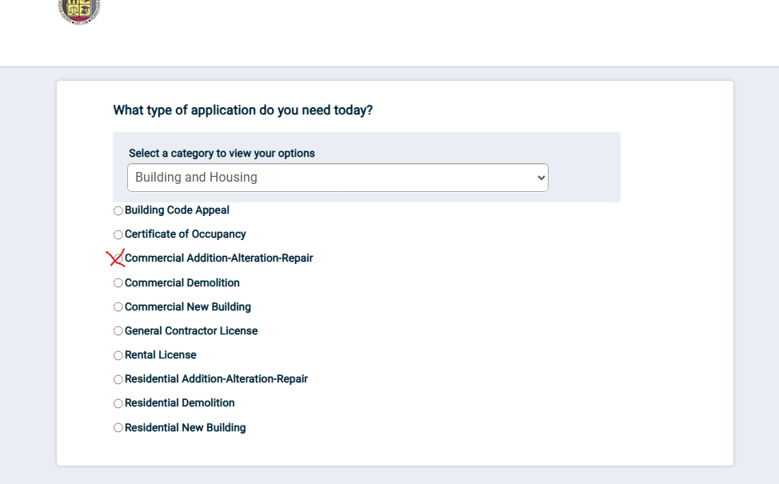

Commercial Addition-Alteration and Repair application for the following items:
- Additions*
- Renovations*
- Demolitions*
- Prefabricated structures*
- Temporary buildings
- Electrical systems*
- Plumbing systems*
- HVAC systems (heating, ventilating, air conditioning)*
- Miscellaneous residential (fireplace, pools, decks, etc.)*
- Grading
* Borough of West Chester has adopted all 2021 IBC-Residential Codes effective January 1, 2026

Complete seven (7) sections of the application:
- My Project
- Contacts
- Contractors-Per ordinance all Electricians, Mechanical (HVAC), Plumbers must be certified through the International Code Council (ICC) and provide the Borough with their certification
- Details
- Valuations
- Submittals-Requires construction plans stamped by a design professional
- Conditions-Historical Architectural Review Board (HARB) and Floodplain status
- Application Fees may apply

Click the highlighted blue Submit Application button for the review process to begin:

Check the portal anytime for up to date status of application review

