How to apply for a new residential construction permit:
Go to www.west-chester.com
Go to Permitting & Licensing Portal:
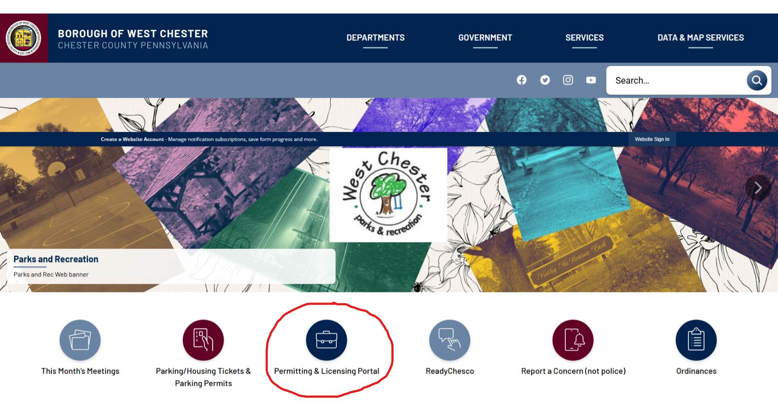
Sign up or Log in:
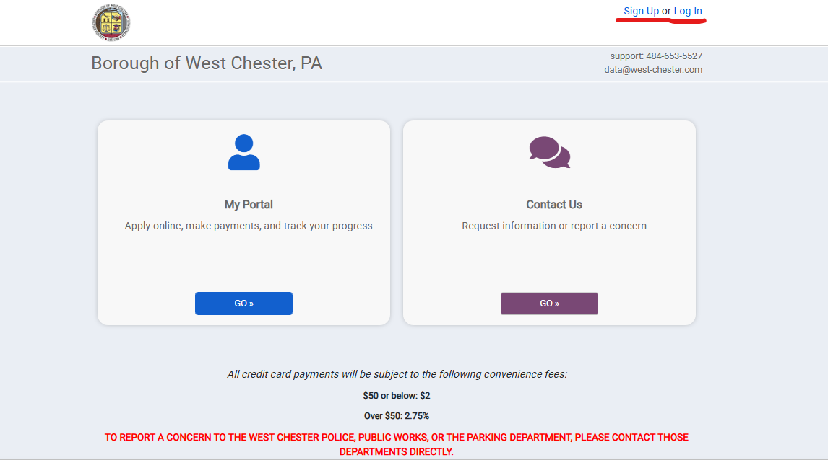
To create an account, provide the following information: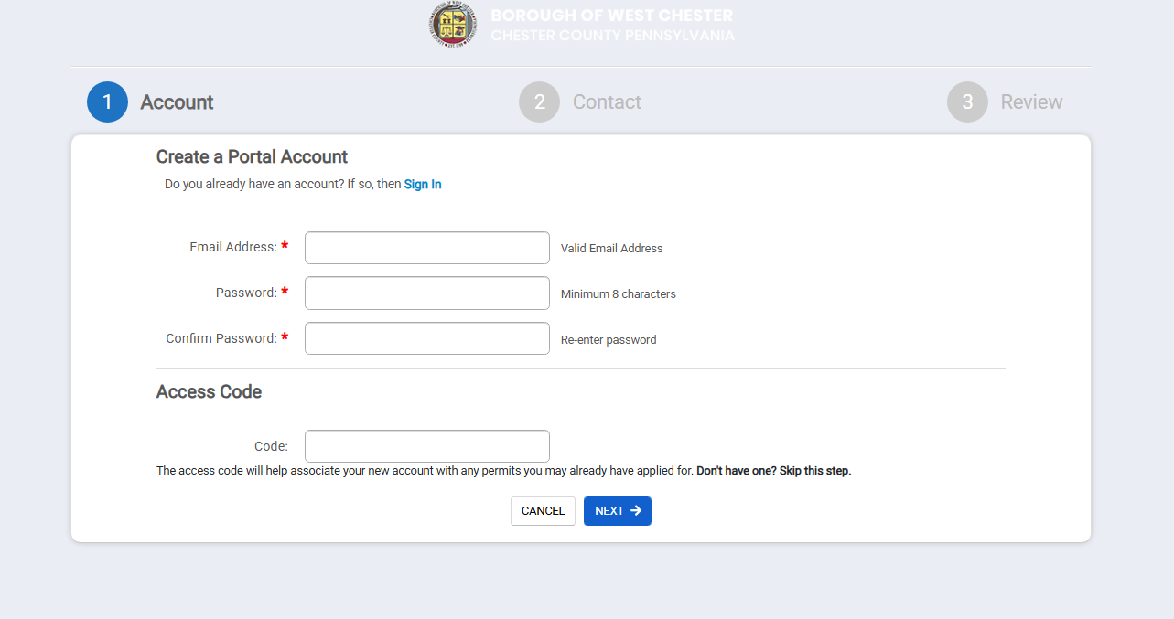
To log in:
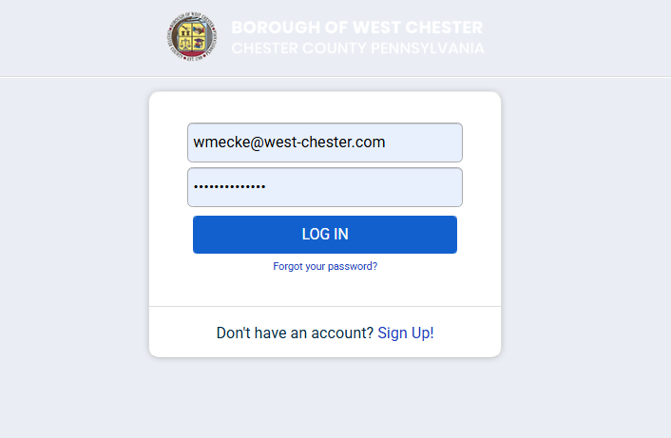

Apply for Residential New Building application:
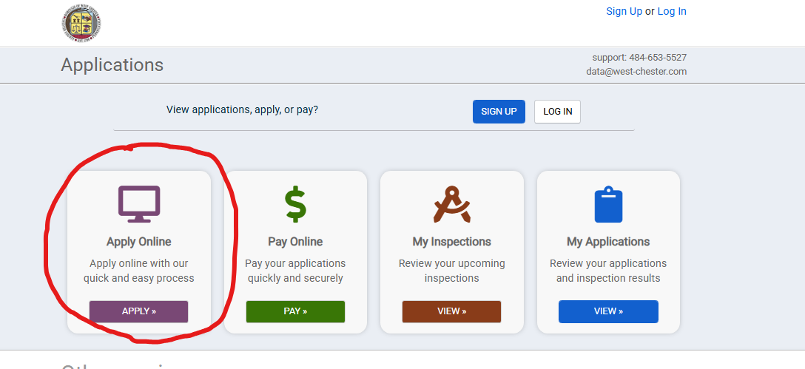
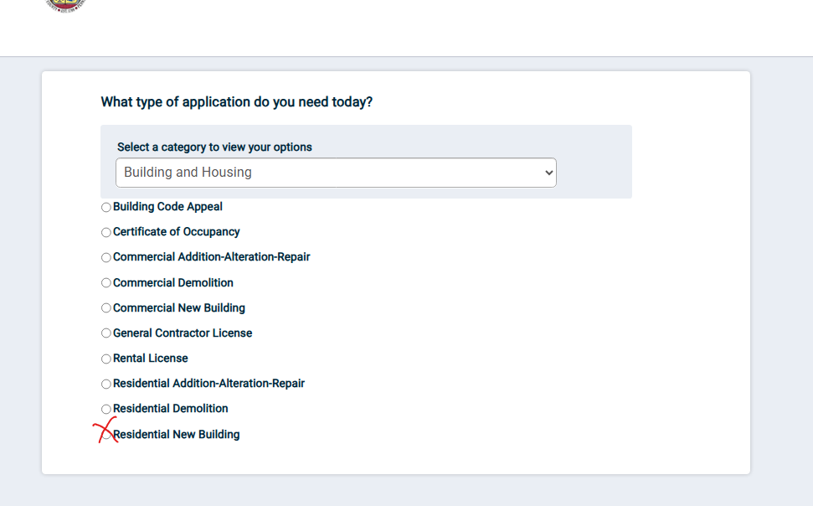
* Borough of West Chester has adopted all 2021 IRC-Residential Codes effective January 1, 2026
* Application for buildings with 3 or more apartments is a commerical application
Complete seven (7) sections of the application:
- My Project
- Contacts
- Contractors-Per ordinance all Electricians, Mechanical (HVAC), Plumbers must be certified through the International Code Council (ICC) and provide the Borough with their certification
- Details
- Valuations
- Submittals-Structural projects require plans stamped by a design professional
- Conditions-Historical Architectural Review Board (HARB) and Floodplain status
- Application Fees may apply

Click the highlighted blue Submit Application button for the review process to begin:

Check the portal anytime for up to date status of application review

